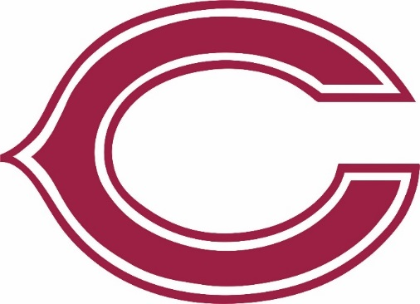
Coffee County Dugout Club
P.O. Box 3304
Douglas, GA 31534
www.coffeebaseball.com

coffeebaseball
Coffee County Dugout Club
@coffee_baseball

Memberships/Corporate Sponsorships

Attention Trojan Baseball Fan:

The 2021 Membership Drive for the Coffee County Dugout Club is in full swing! We appreciate the support of our returning members and look forward to welcoming new families and friends. We are excited that the 2021 Season will be our 51st Season of playing baseball at Coffee High School. There’s no better time to join! Becoming a member of the Coffee County Dugout Club is the perfect way for parents, grandparents, family members, former players, friends of the program, and anyone with pride in Trojan Baseball to show their support.

The Coffee County Dugout Club was formed in 2012 and exclusively supports the Coffee High School Baseball Program. When you join and become a member of the Coffee County Dugout Club, 100% of your donation goes directly to support and benefit the Trojan Baseball Program. As a Dugout Club Member, you will provide both moral and financial support to all Trojan Baseball Players. Your financial donation will primarily be used for:

Purchase of Uniforms & Purchase of Necessary Practice and Game Equipment

It should also be noted that all donations are 100% tax deductible. If you, your business, organization, family or friends would like to help support the Trojan Baseball program, please become a member. Thank you in advance for your generosity and continued support, from the coaches, our players and their parents as well!
$1400 Value
Best Value

Maroon Membership = $150
Membership, All Games Season Pass,
1 Coffee Hat or T-Shirt
Add All Games Season Pass: $100

White Membership = $100
Membership, Varsity Games Season Pass,
Add Varsity Games Season Pass: $50

Gold Membership = $100
Membership, Sub-Varsity Games Season Pass,
Add Sub-Varsity Games Season Pass: $50

Gray Membership = $75
Membership, Middle School Games Season Pass,
Add Middle School Games Season Pass: $25
Membership = $50
Membership Only

Grand Slam Corporate Sponsorship = $1000
Full page ad in program, Game night sponsor at a home Varsity Game (your sponsorship allows ALL STUDENTS to get in free PLUS recognition as the game night sponsor), (4) All Games Season Passes, hole sponsor and team at Trojan Golf Tournament (Date TBD), recognition at baseball clinic (Date TBD).
$600 Value
Homerun Corporate Sponsorship = $500
1⁄2 page ad in program, Game day recognition, (2) All Games Season Passes, hole sponsor at Trojan Golf Tournament (Date TBD), banner recognition at baseball clinic (Date TBD).
$350 Value
Triple Corporate Sponsorship = $300
1⁄4 page ad in program, Game day recognition, (1) All Games Season Pass, recognition at baseball clinic (Date TBD).

2021 Coffee County Dugout Club Membership Form

Individual or Business Name: ___________________________________________________

Contact Name (if different): ____________________________________________________

Address: ____________________________________________________________________

Phone Number: ______________________________________________________________

Email Address: _______________________________________________________________

Please check beside the level you wish to join. Any and all donations will be greatly
appreciated.

Individual:
Hat Shirt
Size _____
_____ Maroon $_________

_____ White $_________

_____ Gold $_________

_____ Gray $_________
Corporate:

_____ Grand Slam @ $1000

_____ Homerun @ $500

_____ Triple @ $300

50
_____ Member $_________

For more information, email us @ coffeedugoutclub@gmail.com

We must receive your membership form and payment as soon as possible to ensure that you receive your Membership Package in time before the season kicks off.

Please make checks payable to:
Coffee County Dugout Club

Return this form and payment to:
Coffee County Dugout Club
P.O. Box 3304
Douglas, GA 31534

